**Projects Configuration Document**

**Tools need to be download and install.**

1. **Download Java 11 /17 and install.**

**Download link.**

<https://www.oracle.com/java/technologies/javase/jdk17-archive-downloads.html>

**Install java and set environment path – JAVA_HOME**

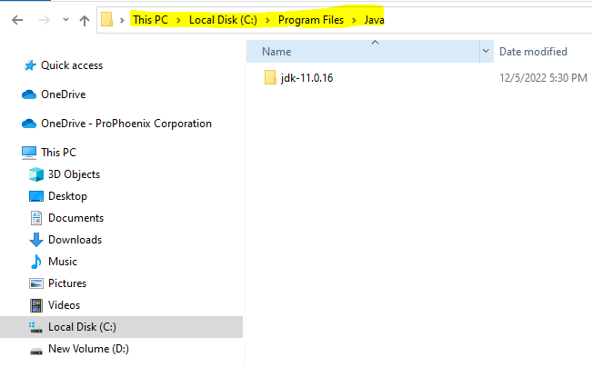

1. **Download MAVEN and unzip.**

**Download link:** [**https://maven.apache.org/download.cgi**](https://maven.apache.org/download.cgi)

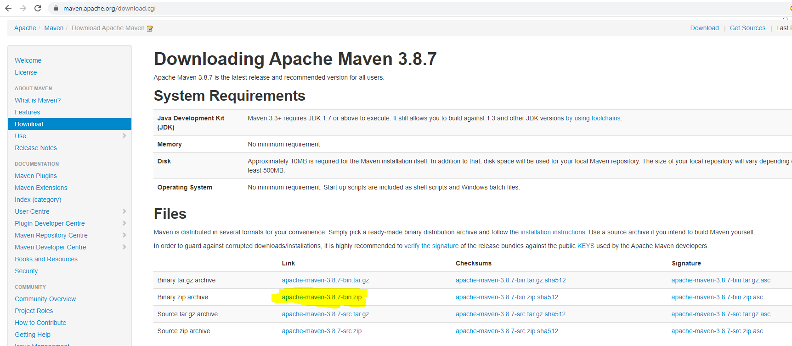

**Unzip maven and set environment path – MAVEN_HOME**

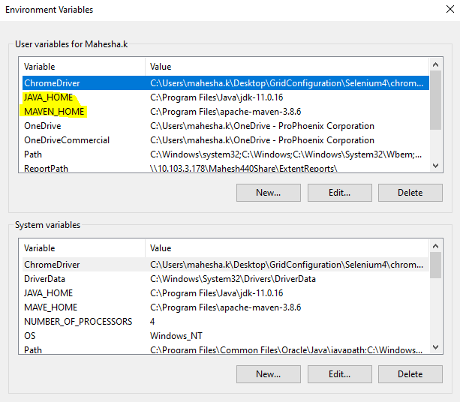

1. **Download latest version eclipse for java developers.**

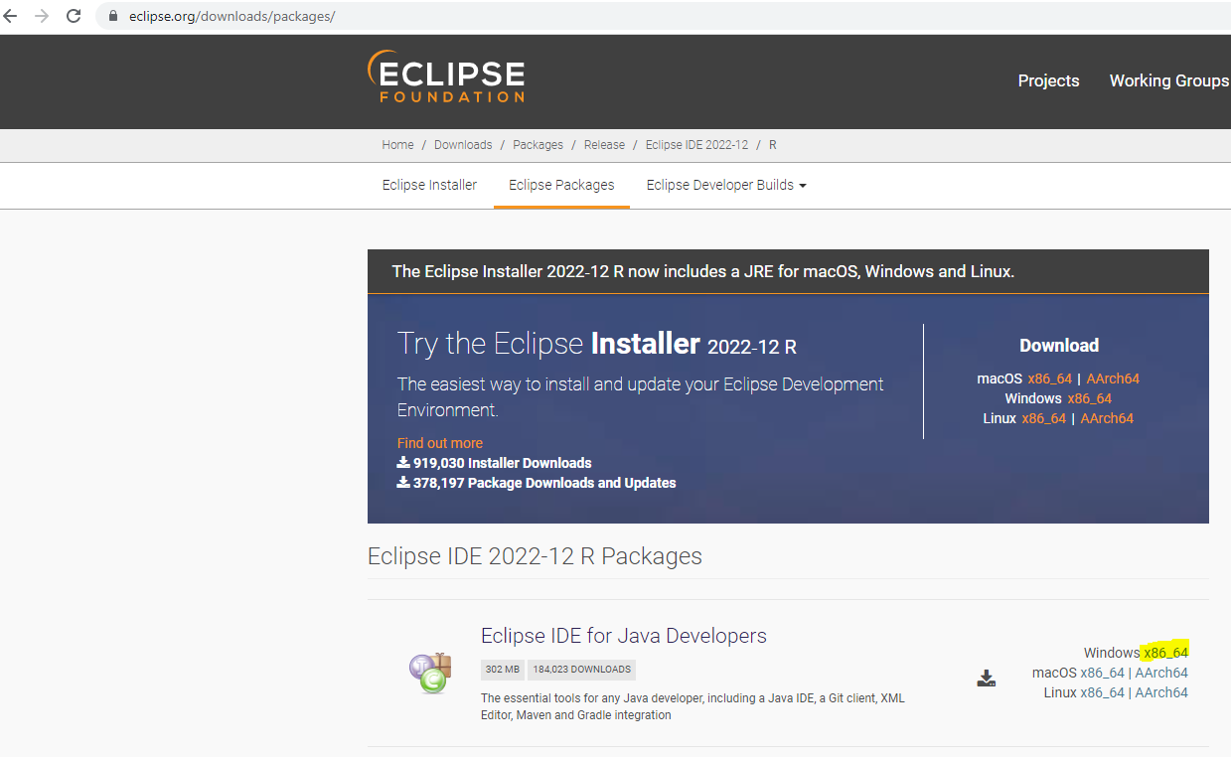

**Once Eclipse Downloaded Verify below Mentioned Plugins Installed**

* **EGit**
* **M2E**
* **TestNG**

1. **Open Eclipse Import projects to eclipse from Local Folder**

1. **Open Eclipse Import projects to eclipse from GitHub.**

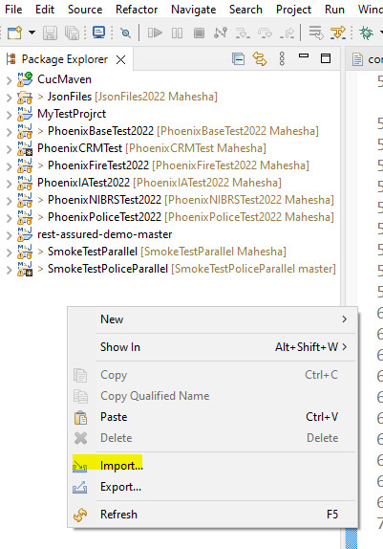

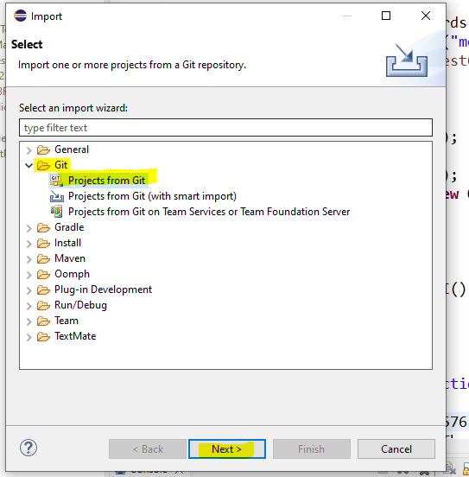

1. **Import Repository Source click on Clone URL and click on Next**

**Open Chrome and hit URL:** [**https://github.com/login**](https://github.com/login)

**Login to GitHub, click on Profile, Click on your Organization.**

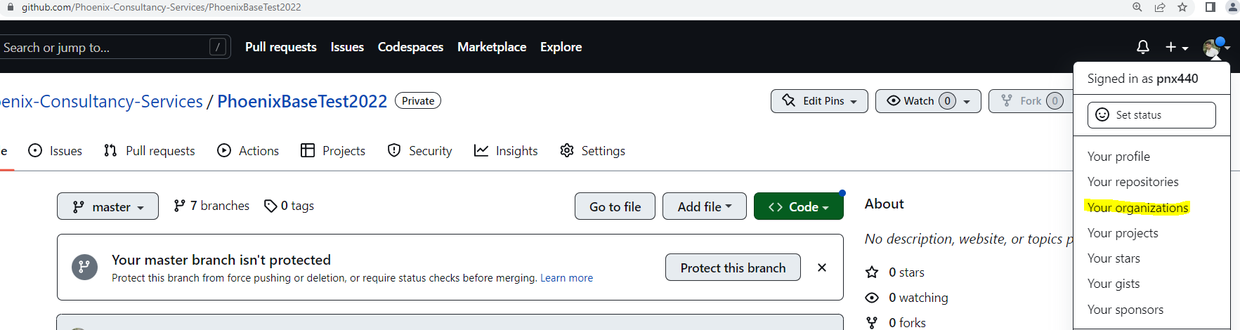

**Select Project need to Import and Copy Repository URL of Project**

**Get back to Eclipse and Paste URL copied from GitHub and Enter Login Credentials**

**UserName and Personnel token , Click next**

**Select Branch to Clone and Click next Until Project Cloned to Eclipse**

Project has been cloned to IDE successfully Follow the same Process to Clone all the Needed Projects.

Once Cloned Verify Project the Branch Mapped to Your Branch, If not Follow Below steps to Switch to your Branch

**After all the process Follow below steps to take Maven build**

**Clean Projects target folder Jars**

**mvn clean**

To Build Projects

mvn build

Project Installation

mvn install

Projects Are ready - To run scripts Connect hub & Nodes,

refer doc - [Selenium Grid](https://prophoenix.sharepoint.com/:w:/r/sites/Engineering/Shared%20Documents/QA/Test%20Automation/Automation%20Projects%20and%20Detailed%20structure%20Documents/CICDPipelines/Grid%20Configuration.docx?d=w41997549875446f89d71164f10fba8a1&csf=1&web=1&e=mirige)